Record No: 0564
ELIZABETH BELLINGHAM(Eliza)

2nd daughter of Col Henry Bellingham (0565) of Castle Bellingham and Eliza Tenison,
natural daughter of Richard Tenison(1734-1779), son of Thomas Tenison,(1706-1758)
Judge of the Court of Common Pleas.

Birth: 5 Sept 1779
Marriage: 30 Aug 1800 at Roscrea, Co Tipperary, Capt. William Somerville
Death: 16 Dec 1839

Notes:
SR1636 Parish records: She was buried on 19 Dec 1839 at St Audoen’s Dublin.

,

Source: Somerville Index.

Further Research:
Colonel Henry BELLINGHAM was born about 1739 in Castlebellingham, Co Louth, Ireland. He died on 10 Sep 1800. He married Elizabeth TENISON on 1 Jun 1772 at St. Mary's, Dublin.
Elizabeth TENISON was born about 1750 in Thomastown, Co Louth, Ireland. She died on 14 Sep 1814 in Ardee, Co Louth, Ireland.
NB Further research is required to verify the dates of birth and death of Thomas Tenison and Richard Tension.
They had the following children:
 | M | i | Alan BELLINGHAM was born about 1776 in Castlebellingham, Co Louth, Ireland and died in London in 1821, buried at St Mary Abbot’s, Kensington. He married Monique Baby of a French Canadian Family in Canada; she had a full life but became estranged from her husband. Substantial research has been undertaken. See the article “Monique Bellingham -Lyme’s Canadienne” by Keith Shaw. Monique had at least 3 children Eliza born 1795,Susan born 1797 and William born 1801.--------These eldest 3 were born in Canada, the above article suggests there were 4 more who would have been born at Castle Bellingham but the writer may have confused the two youngest, named Dorothea and Henrietta, with their aunts .This interesting article explains why Alan and, subsequently, Monique, lost the Castle Bellingham estate, which was limited in size and totally unprofitable, to his rich uncle Sir William Bellingham who had been secretary to Pitt and was childless. There is a portrait (reputedly) of Monique Baby at Dargle Hill and a miniature , again reputedly, of Alan; Alan was said to be wicked and so labelled, the miniature clearly shows Down Syndrome features. These both came from Castle Bellingham.
 | F | ii | Dorothea Bellingham was born before 1779. She married 4th January 1798William Riall of Annerville, Clonmeldied March 1848
 | F | iii | Elizabeth BELLINGHAM was born 5th September 1779, married 30th August 1800 Capt William Somerville of Ardrass, Celbridge, Co Kildare and died 19th December 1839.
 | F | iv | Henrietta Martha BELLINGHAM was born about 1782, married in 1799 Andrew Arthur Riall of Annerville and died before 1818..
 | M | v | Henry Tenison BELLINGHAM was born about 1786 in Castlebellingham, Co Louth, Ireland. He died on 6 Apr 1812 at Badajoz, Spain. He was buried in 1812 in Castlebellingham, Co Louth, Ireland.

http://bellinghamroot.tripod.com/bellingh/pafg06.htm#68

NB The above extract has been corrected by WBRBS from reference to LG of Ireland 1952 Edition ‘Riall of Ballyorney House’ and the Somerville records. Dorothea married William Riall of Annerville, Clonmel, Co Tipperary while her youngest sister married his youngest brother Andrew Arthur Riall. The Rialls were bankers in Clonmel, a prosperous milling town. The Riall family, but not the direct descendants of the above, subsequently married into the Roberts family of Old Conna Hall, near Bray, Co Wicklow, which they inherited. (It is now(2011) a prep school). They then moved to Ballyorney, near Enniskerry where Patrick (Dudley Erskine) Riall and his wife Jane and family became close friends of WBRBS and Manon. Manon taught the Riall children to ride, Selina and Caroline Riall were her bridesmaids and Selina’s elder daughter is Manon’s goddaughter. Patrick and Jane were walking companions of WBRBS and Manon on the continent over a five year period. After the death of Patrick’s sister (2010), her sons insisted that her portrait of Dorothea should join her Bellingham relations at Dargle Hill. This is fitting as Dorothea Riall, referred to as Dora R in Capt William’s diary, was obviously close to her sister Eliza Somerville, and is frequently mentioned in the Diary and the family correspondence. Archibald James Somerville, before his flight to Barbados in February 1823, spent three days at Clonmel before embarking on the George and Thomas. The purpose of the visit has occasioned much speculation.

Eliza, from her correspondence, is a loving mother of a widely scattered family, pleading with them to keep in touch with her and their siblings. From the sons’ status in life we are lead to believe that their circumstances fell far short of those to which Eliza and her sisters were accustomed. Eliza was constantly concerned that they should marry well and gain good appointments, if necessary, through Bellingham contacts. She also remembers her brother Tenison fondly in her correspondence.

While no portrait of Eliza survives, there are sillhouettes, and a photograph of an unfinished painting said to be Eliza at Dargle Hill. There is also a miniature painting of Henry Bellingham. There is also a miniature of Judge Tenison.

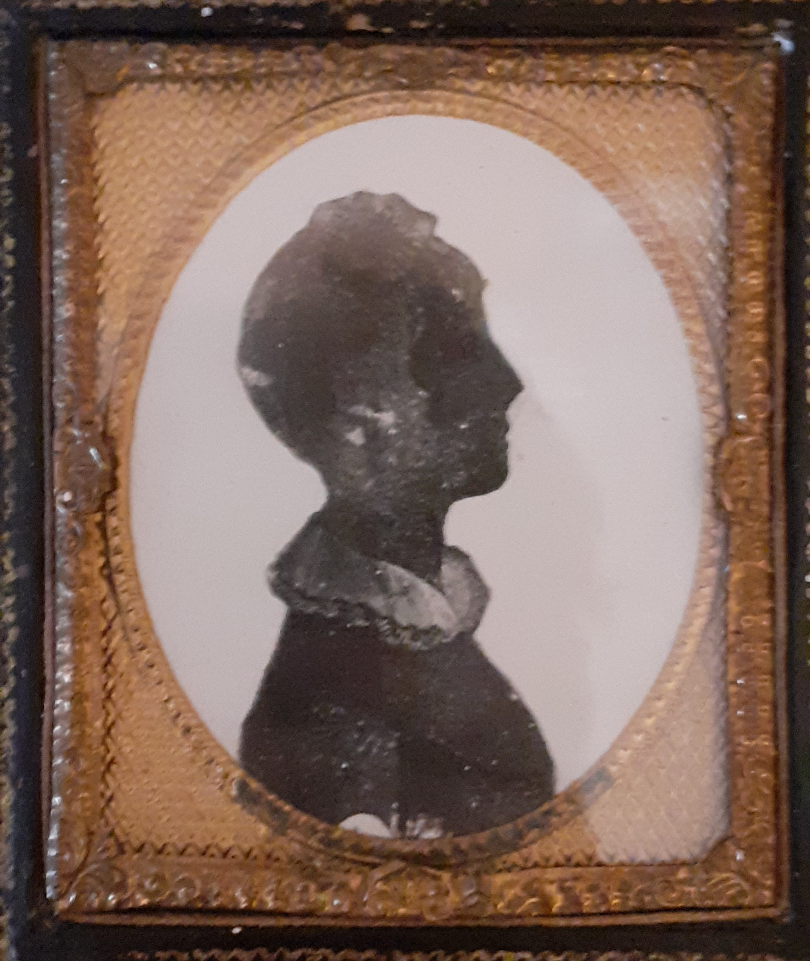

Eliza Somerville (nee Bellingham) 1779 -1839
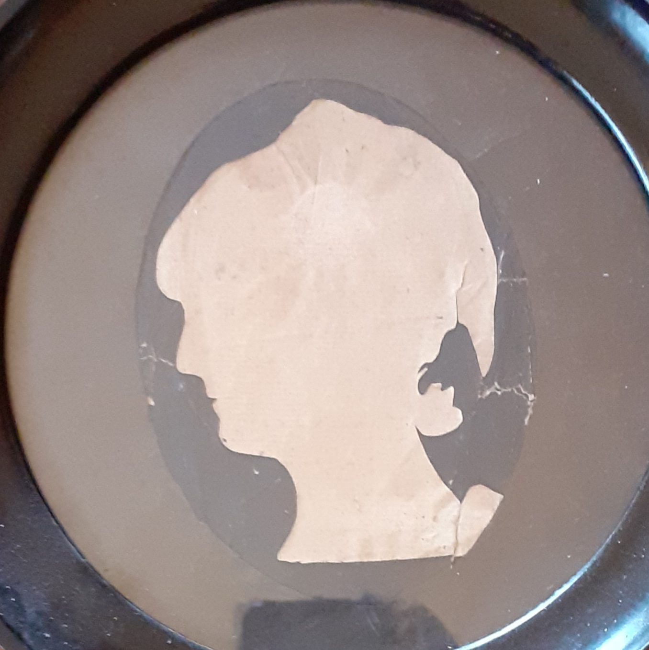

Eliza Bellingham (nee Tenison) 1750-1814
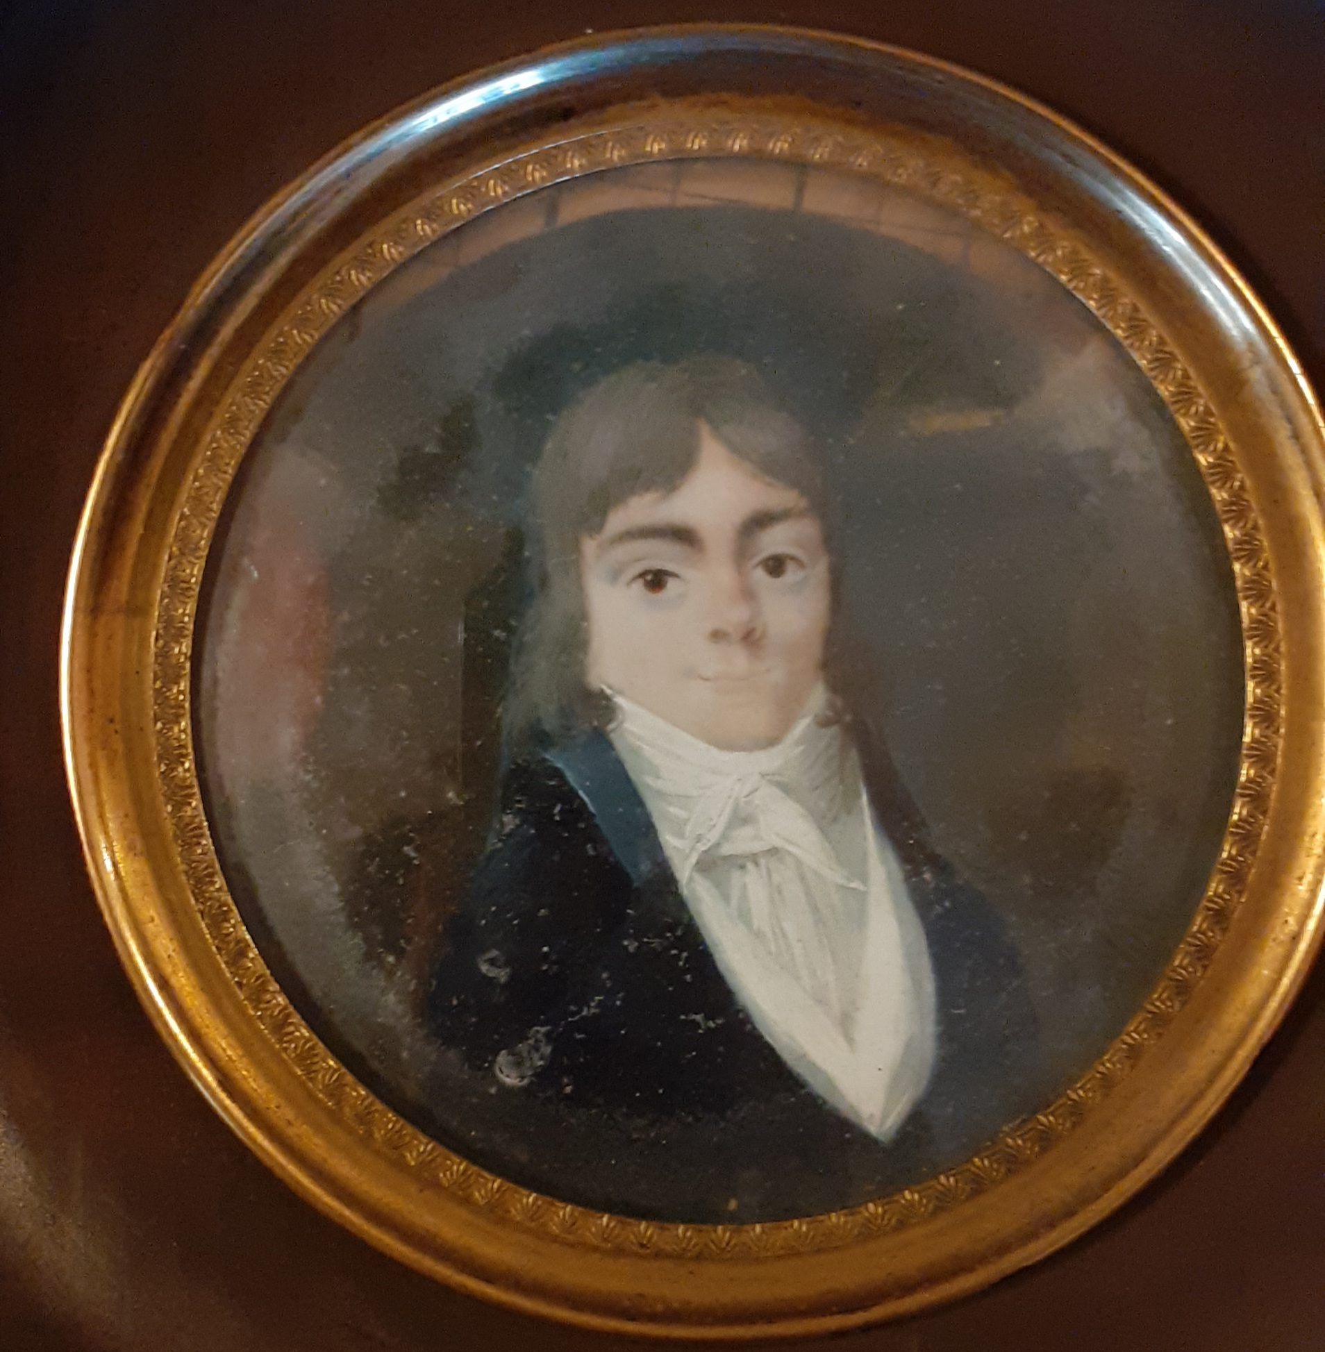

Alan Bellingham (believed to be wicked Alan) 1776-1821
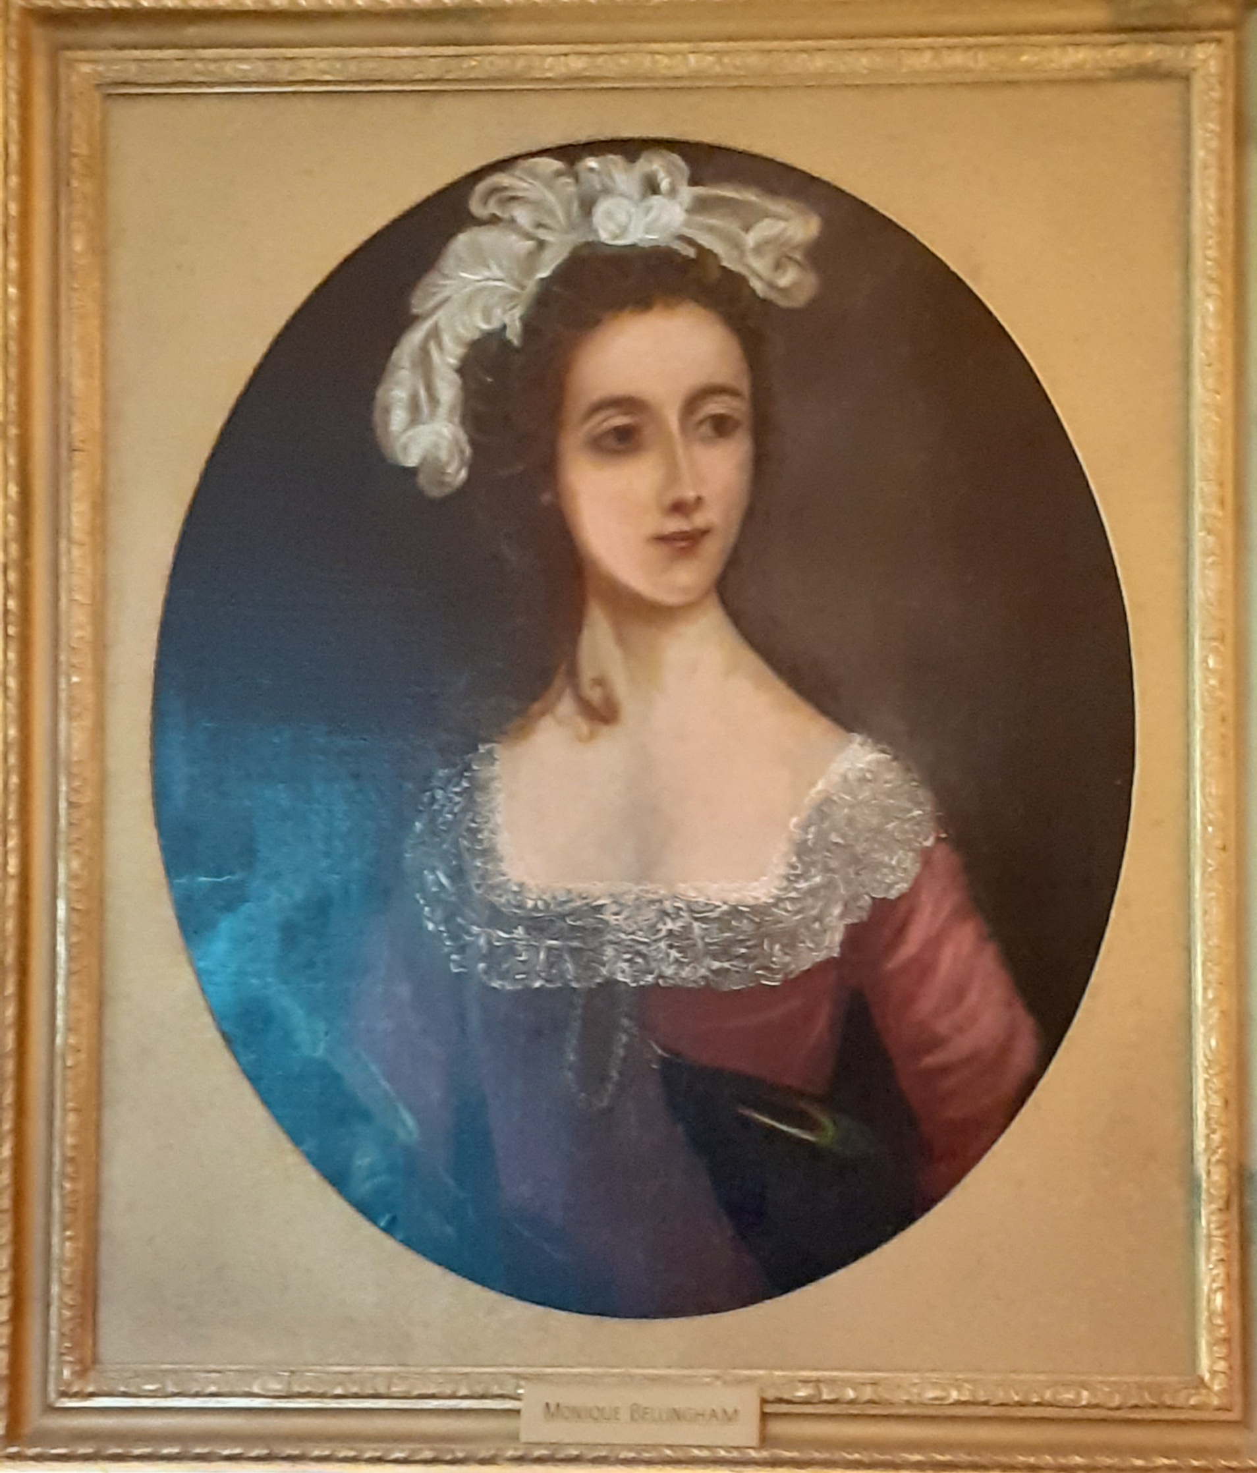Monique Baby {sometimes referred to as Monique Bobbet) 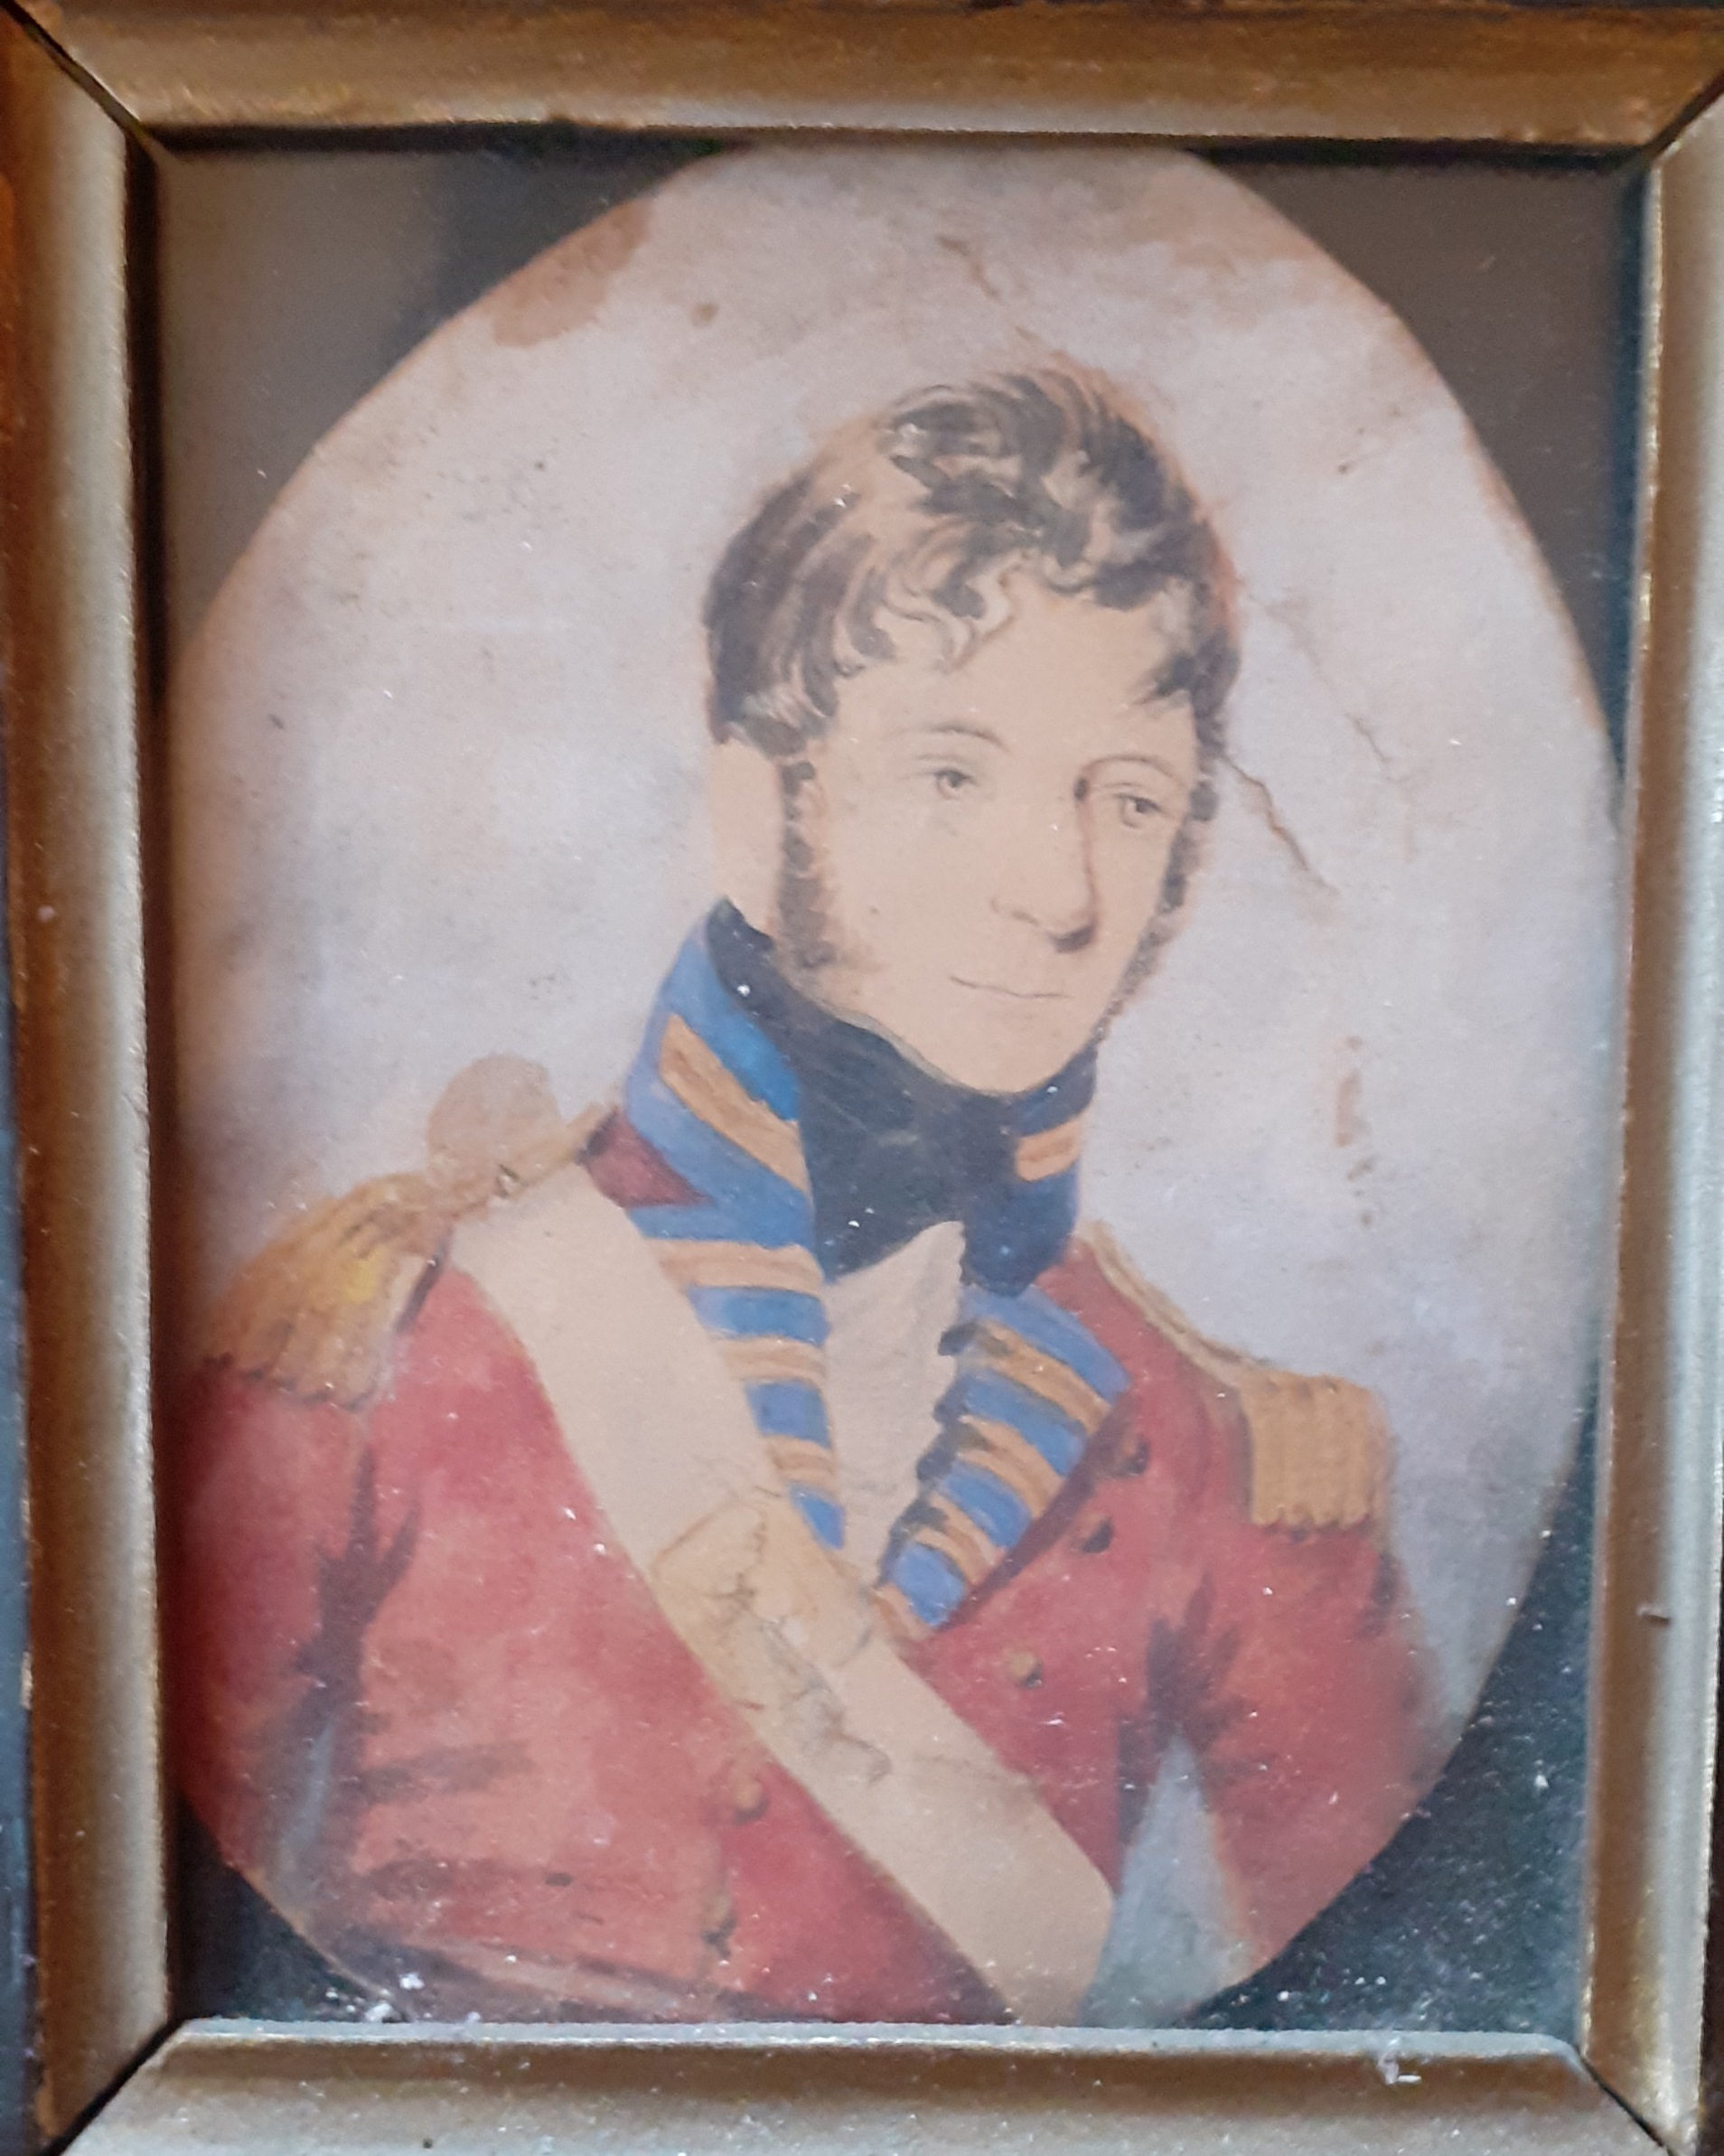
Henry Bellingham younger brother of Eliza Somerville (nee Bellingham) born about 1786 killed at Badajoz 6 April 1812

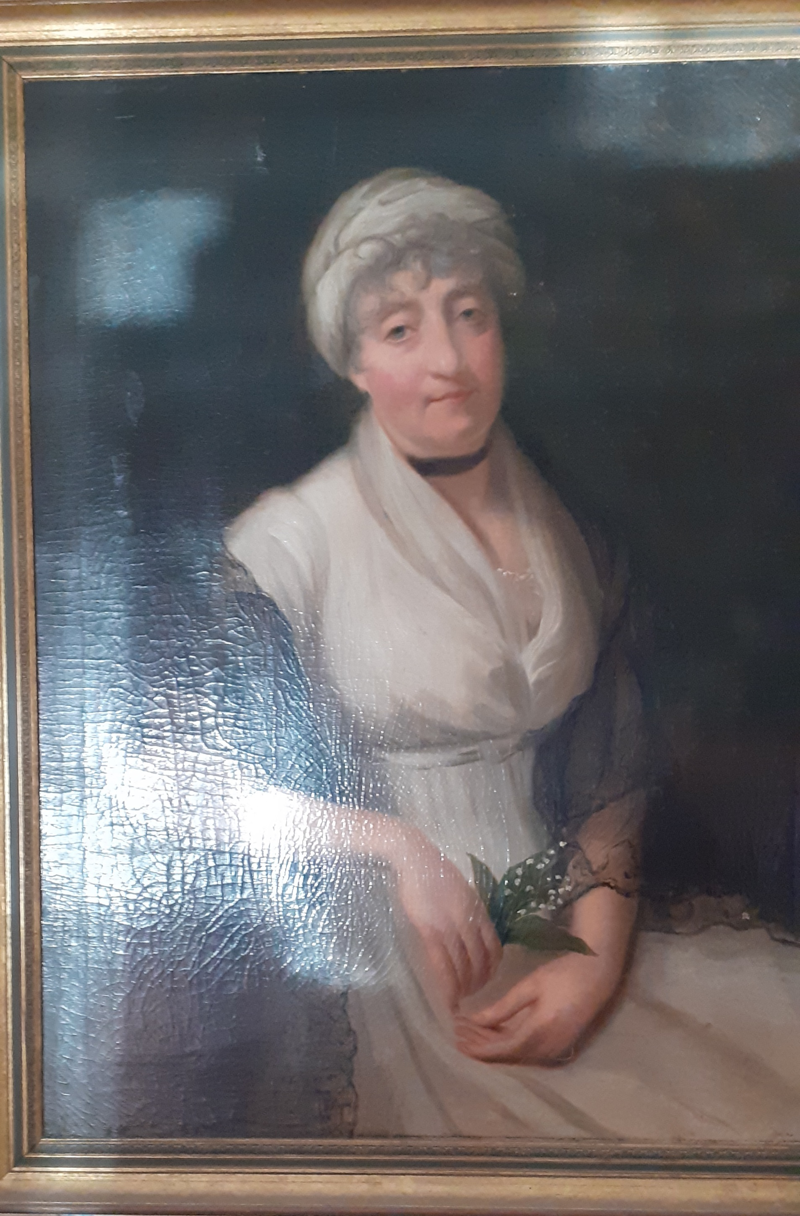

Dorothea Riall (nee Bellingham) born before 1779 died 1848

